Roll Drive Design Considerations
for
Steel Mill Rolling Operations
Presented By
Patrick M. Laughery
&
Daniel J. Rosseljong
Sumitomo Drive Technologies

For
Maintenance Guild Annual Meeting
San Antonio, TX
March 21, 2007

The conveying system that links one process to another is the lifeblood of any rolling mill. Lose this ability to move product and you lose production. As anyone in the steel industry knows, if a single component can shut down production of a multi-million-dollar steel mill, this component justifies individual design consideration.

Preventative maintenance procedures, spare parts procurement, system monitoring and rapid change out procedures are some design considerations for components critical to production. Rolling operations consider the electro-mechanical system that delivers power to the roll drives a “critical to production” component.

Many older designed mills utilize single drive systems (motor, coupling and speed reducer) to power several conveyor rolls. This design uses a single motor, coupling and speed reducer to drive the primary roll, while four to five other rolls are coupled, or slaved to the prime mover utilizing a roller chain.

Technology has improved many processes of the rolling operation, including the modernization of the roll drive. While the concept of the single drive system is cost-efficient up-front, it is costly in lost production if a problem develops with one of the drives. In this case, if one drive fails, multiple rolls shut down, eliminating the ability to transfer steel fast enough to keep up with production. The overall cost of the individual roll drive approach is considerably lower because it increases productivity and savings by significantly reducing downtime.

Since it has been established that roll drives are critical to production and individual roll drives are becoming the standard for the industry, the next logical step is to establish critical design criteria to evaluate speed reducer capabilities. In order for a reducer to perform in the rolling operations of a steel mill, it must meet the following:

Reliability: Speed reducers that power the rolls on a roller table conveyor must be reliable. The operation of the conveyor must not be plagued with unexpected interruptions or downtime.

Speed reducers are a key component in the power transmission chain (along with motors, bearings, couplings, etc.), and must be highly reliable, not subject to excessive maintenance or failures. They must be able to withstand the extreme conditions of the steel mill, day after day, year after year, to maintain the operation of the roller conveyor and ensure uninterrupted production.

High Shock Load Capabilities: It is no surprise that this is a critical design element for a reducer operating in a steel mill. Non-uniform and heavy shock loads are considered normal operating conditions. Many design engineers handle this requirement by increasing the service factor of the gearbox. According to the American Gear Manufactures Association (AGMA) selection criteria, reducers can be selected by Service Factor or Load Classification. Both are a means of classifying different equipment and applications into a uniform guideline useful for reducer selection. For Metal Processing, AGMA makes the following recommendations:
However, service factor is not the only consideration when designing for heavy shock load. Housing construction and gear design are also critical to increasing the durability of the gearbox.
Table 1 | SERVICE
 | CLASS |  | FACTOR
Application | 10 HRS /DAY | 24 HRS /DAY | 10 HRS/DAY | 24 HRS /DAY
METAL MILLS
Table Conveyors

Non-Reversing
Group drives | II | III | 1.25 | 1.5
Individual | III | III | 1.75 | 2.00
Reversing | * | * | * | *
* Consult Factory

The following are the design criteria for high shock load requirements:
- Service Factor no less than 1.25
- Ductile Iron housing to withstand high shock
- Internal Component Design to include:
  - Bearing Grade Steel, Heat Treated
  - Strict Tolerances
  - Precision Finish

Superior Sealing Capabilities: The leading cause for gearbox failure is environmental contamination. The steel industry, especially the rolling operations of a mill, is perhaps the most demanding environment of any industry. To survive, a gearbox must protect itself from heat, moisture, chemicals and air-borne contaminates.

If seal integrity is lost, the gearbox lubrication will be compromised. Once the lubrication is lost or contaminated, bearing failure will result. In many instances, bearing failure will be catastrophic causing additional damage to internal gearbox gearing.

The following are the design criteria for the gearbox seal:
- Superior barrier to keep contaminates out of the gearbox.
- Exceptional oil containment.
- Optional seal composition that will increase the chemical resistance and operating temperature of the gearbox.
- Seal must be readily available and stocked by local power transmission distributors.

Compact Design: Often, the speed reducer must physically fit into a limited size envelope. It must be of compact, power-dense design, so that even high ratio units are not bulky or heavy. Individual roll drive designs, in particular, are subject to restrictive space limitations.
Versatility: To accommodate variations in design, motor requirements, input speeds and ratios, the selected reducer must be very versatile.

The following criteria must be adaptable, allowing designers to develop a configuration based upon system requirements:
- Motor Mounting
  - Integral Motor
  - C-Face Adapter with coupling
  - C-Face Flange with hollow keyed input
  - Top Mount
  - Shovel Base Mount
- Mounting Configuration
  - Foot Mount
  - Wall Mount
  - Flange Mount
- Lubrication
  - Oil Lubricated
  - Grease Lubricated
- Wide Ratio Range

Availability: For standard design, this reducer should be available from the manufacturer in two weeks or less. A two-week lead time is expected for all non-commercial parts such as internal wear parts and shafting.

Emergency “shut down” shipping time should be 1-2 days.
Documentation: Drawing availability in AutoCAD format is essential. Exploded view reducer assembly drawings with part locators should also be available. Operating & Maintenance manuals should also be provided with each reducer.

Industry Proven: This reducer will have a proven history of successful applications within the steel industry. The manufacturer will be capable of producing a library of case studies establishing performance in steel mill operations. If requested, the manufacturer will provide a list of third-party testimonials within the steel industry. Longevity and endurance in the market must be considered. The manufacturer would also demonstrate a genuine interest in serving the steel industry.

Customization Capability: The reducer manufacturer shall demonstrate the ability to modify fit and form design characteristics to provide “drop-in” capability or satisfy other unique application requirements. The selection of special housing material, base to center height, overall length, input and output shaft dimensions and bolt hole locations are all possible design modifications.

After design specifications are established, the next step is to evaluate individual manufacturers. This paper submits the Sumitomo Cyclo® concentric inline speed reducer as the ideal reducer for rolling operations in the steel industry. Each reducer under consideration should be judged by the established design criteria.

Several reducers should be considered. Evaluation of the Sumitomo Cyclo® appears on the pages that follow:

Sumitomo Cyclo Evaluation

Reliability:
The Sumitomo Cyclo drive is unsurpassed by any other inline drive available in the market today. Cyclo’s unique cycloidal design has advantages superior to speed reducers using common involute tooth gears. Cyclo components operate in compression, not in shear. All rotating components are fully hardened, vacuum degassed, bearing grade steel, manufactured to strict tolerances and finishes. Along with the ductile iron housing, this unique design enables the Cyclo speed reducer to provide consistent, reliable performance for years in hostile environments such as steel mills. All Cyclo products are warranted for a full two (2) years of service.

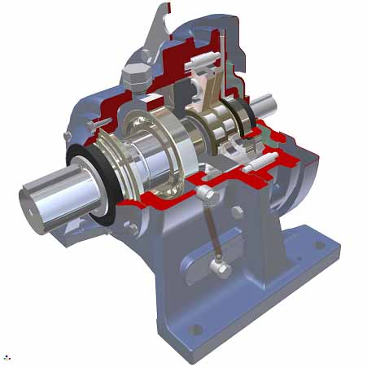

Fig. 1

Fig. 2
Principles of Operation
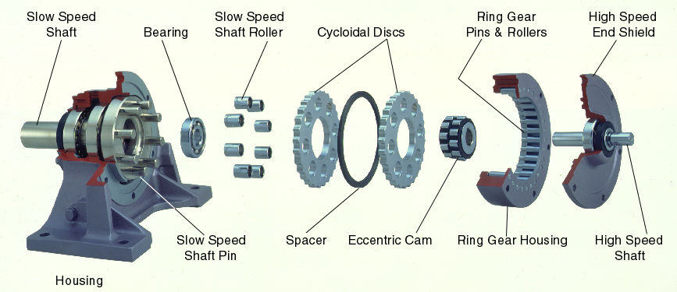

High Shock Load Capabilities:
Unlike gear teeth with limited contact points, a Cyclo has two-thirds of its reduction components in contact at all times. The Sumitomo internal parts are comprised of fully hardened, 52100 bearing steel, produced with stringent tolerances and finishes, which guarantees perfect load sharing among the load-carrying elements. Mill duty Cyclo housings are made from ductile iron, which provides superior shock load capacity when compared to grey iron.

For these reasons, all Cyclo products can withstand up to 500% of catalog ratings for momentary intermittent shock loading. The competition cannot match this performance.

Fig. 3 Fig. 4
Compression Shear
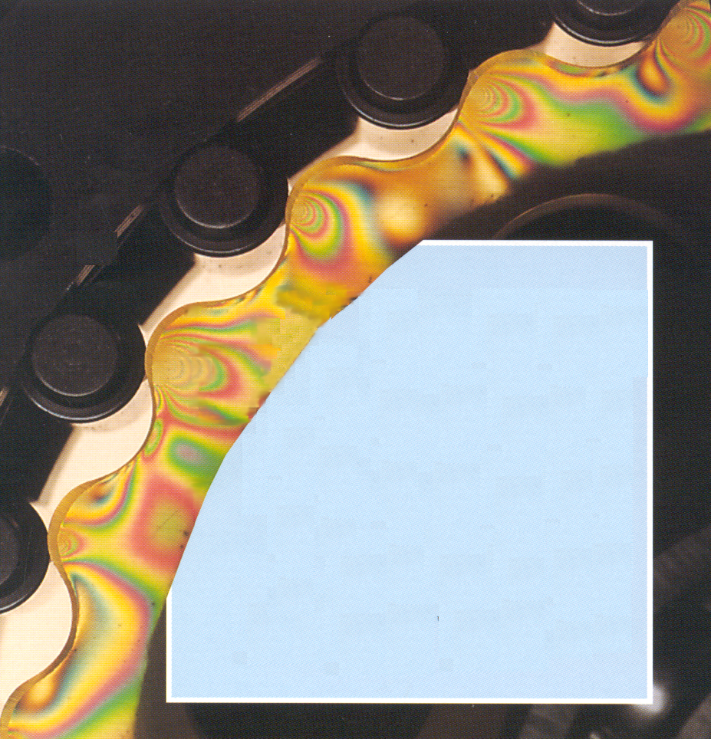


Superior Sealing Capabilities:
Cyclo offers dual double-lip seals that provide several barrier points to keep contaminates out and lubrication in. The outer dual lip seal is the first barrier against external contamination. The inboard seal is a double lip seal that serves as an additional protection barrier and lubrication retention. The Cyclo seal design utilizes plunge-ground, hardened wear sleeves that extend seal life.

These seals are also available in Polyacrylate, Silicon, and Viton material that will provide protection in high or low temperature applications or where chemical resistance is required.

Versatility:
Sumitomo Cyclo offers numerous design configurations regarding mounting configuration, motor mounting, lubrication, and ratio range.

Figure 5 illustrates some of the many motor mounting options available:

Fig. 5

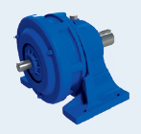 Free Shaft 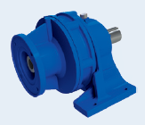 Quill Input

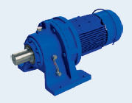 Integral Motor 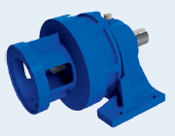 C-Face

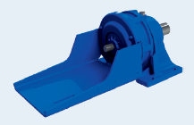 Shovel Base 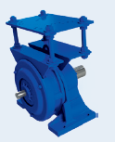 Top Mount

The Cyclo also offers many reducer mounting options. The reducers can be mounted in any orientation (horizontal, vertical or inclined). Mounting options also include foot mounting, wall mounting, and flange mounting. See Table 2, below, for available mounting positions:

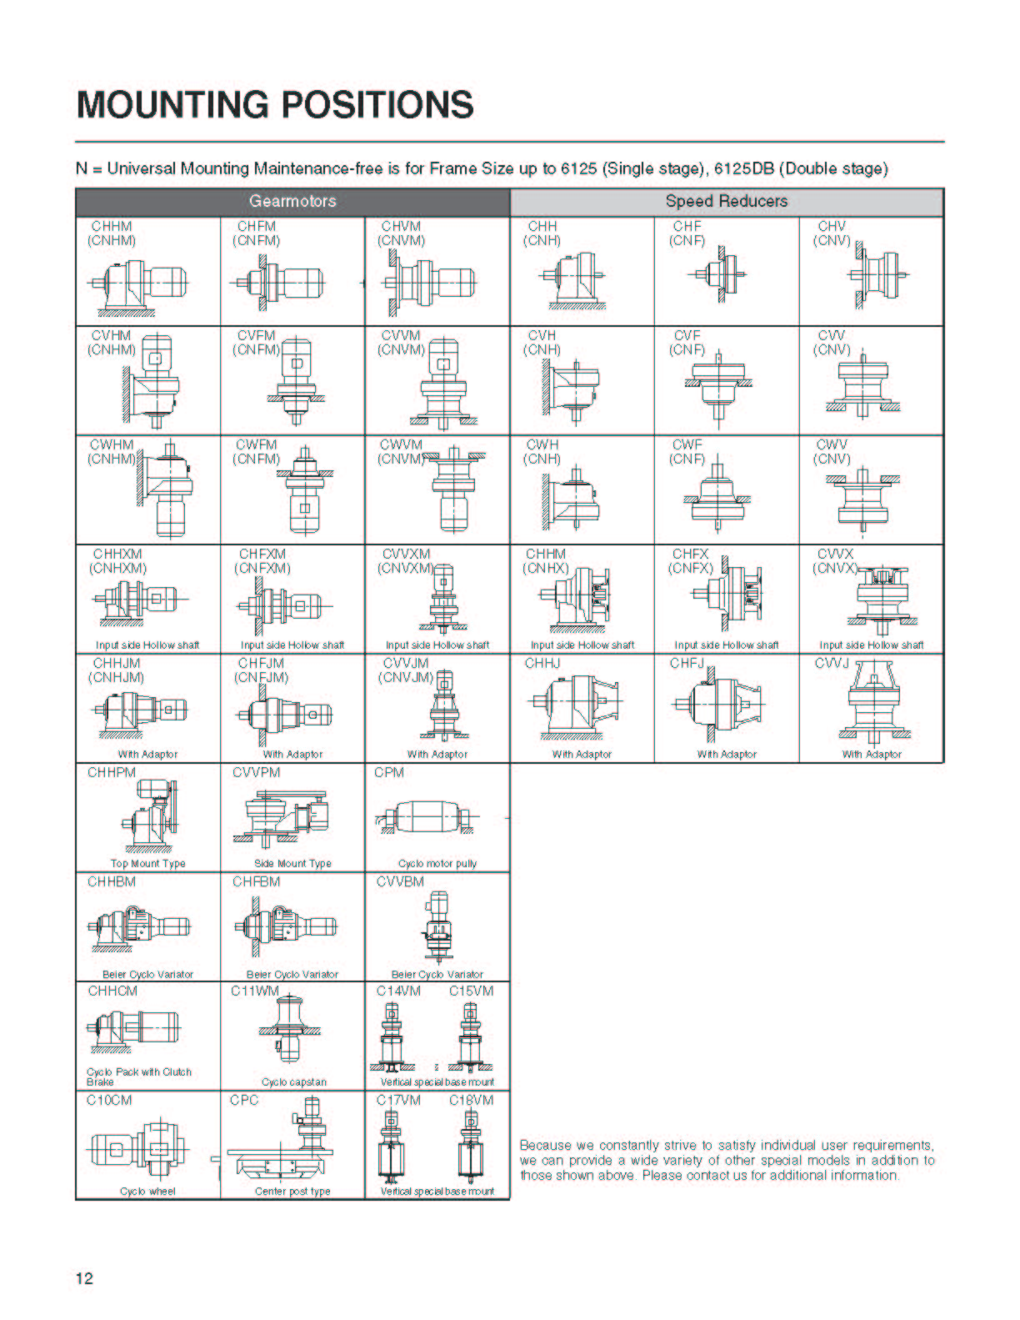
Table 2
Units are available in both oil or grease lubrication. Grease lubricated reducers offer the advantage of low maintenance, and allow for universal mounting configurations. They can be installed in any direction and at any angle without consideration for lubrication flow.

The Cyclo reducer has the distinct advantage of a very wide range of ratios. Due to its unique cycloidal design, ratios of 87:1 (and in some cases 119:1) are attainable with a single reduction stage. Multiple reductions allow Cyclos to operate at very high ratios, while maintaining relatively high efficiency, as seen in the Table 3 below:

Table 3 Available Ratios
Type | Ratio Range | Efficiency (typ.)
Planetary | 3:1 and 5:1 | Up to 97%
Sumitomo Cyclo  Single Reduction  Double Reduction  Triple Reduction | 6:1 to 119:1  102:1 to 7569:1  up to 658,503:1 | 95%  90%  85%

Availability:
All standard parts and assembled reducers are available with a two-week delivery. Emergency breakdown service is available and many gearbox sizes can be shipped from the Sumitomo factory located in Chesapeake, VA, the same day. Sumitomo has additional facilities located across the country in Glendale Heights, IL, (Chicago), Verona, VA, Lufkin, TX, and Corona, (L.A.), CA. Local distribution also plays a significant role in assisting with emergency repair. Some distributors have invested in “build shop” capabilities. These “build centers” inventory reducer components and have the ability to assemble and ship a reducer the same day.

Documentation:
Cyclo drawings in AutoCAD format, either as a two-dimensional outline or three-dimensional solid model, are available from Sumitomo. Exploded view drawings showing all Cyclo internal and ancillary components, with part locators are also available. Installation & Quick Start guides are shipped with each reducer. Detailed operating and maintenance manuals are available for download from sumitomodrive.com and include assembly views with commercial and non-commercial parts lists, lubrication information, and assembly/disassembly instructions.

Fig 6 is an example of an exploded parts drawing for a Cyclo model 6185:

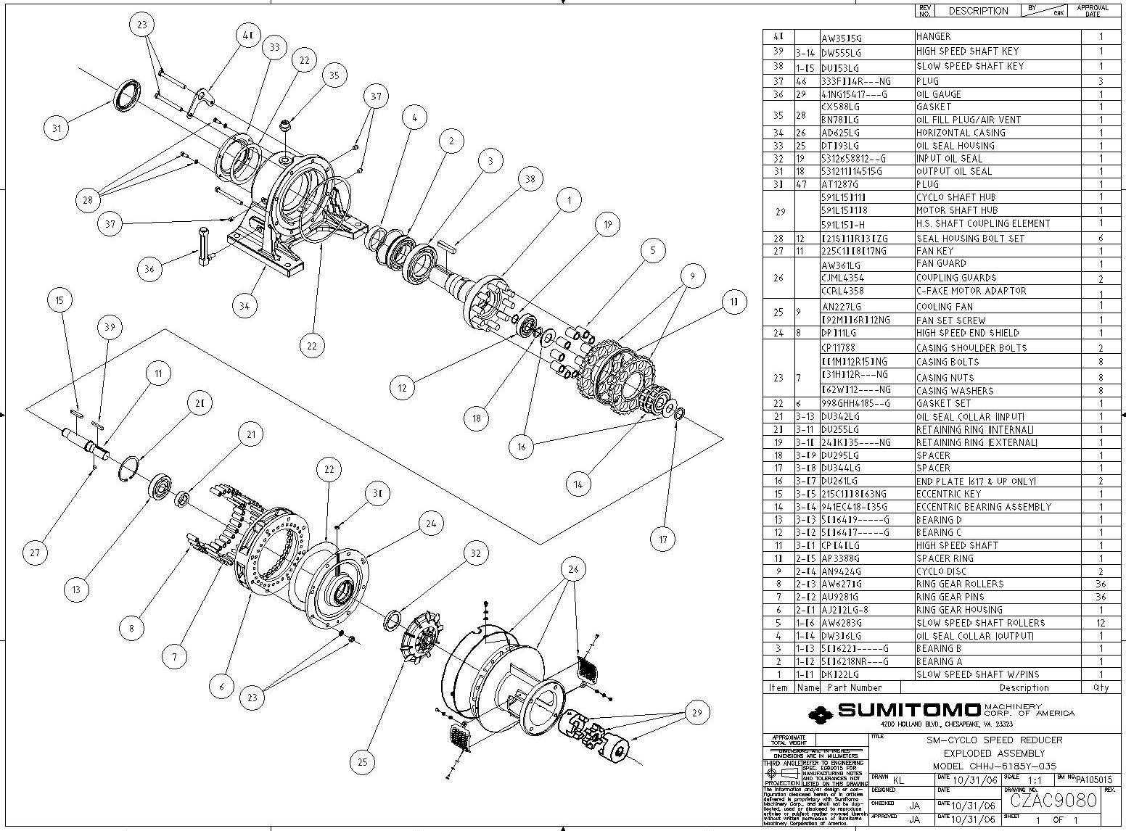
Fig 6.

Industry Proven:
Sumitomo Cyclo speed reducers have a proven track record of solving difficult applications within the steel industry. Figures 7-12 are a few examples of Cyclo reducers’ solution capabilities:
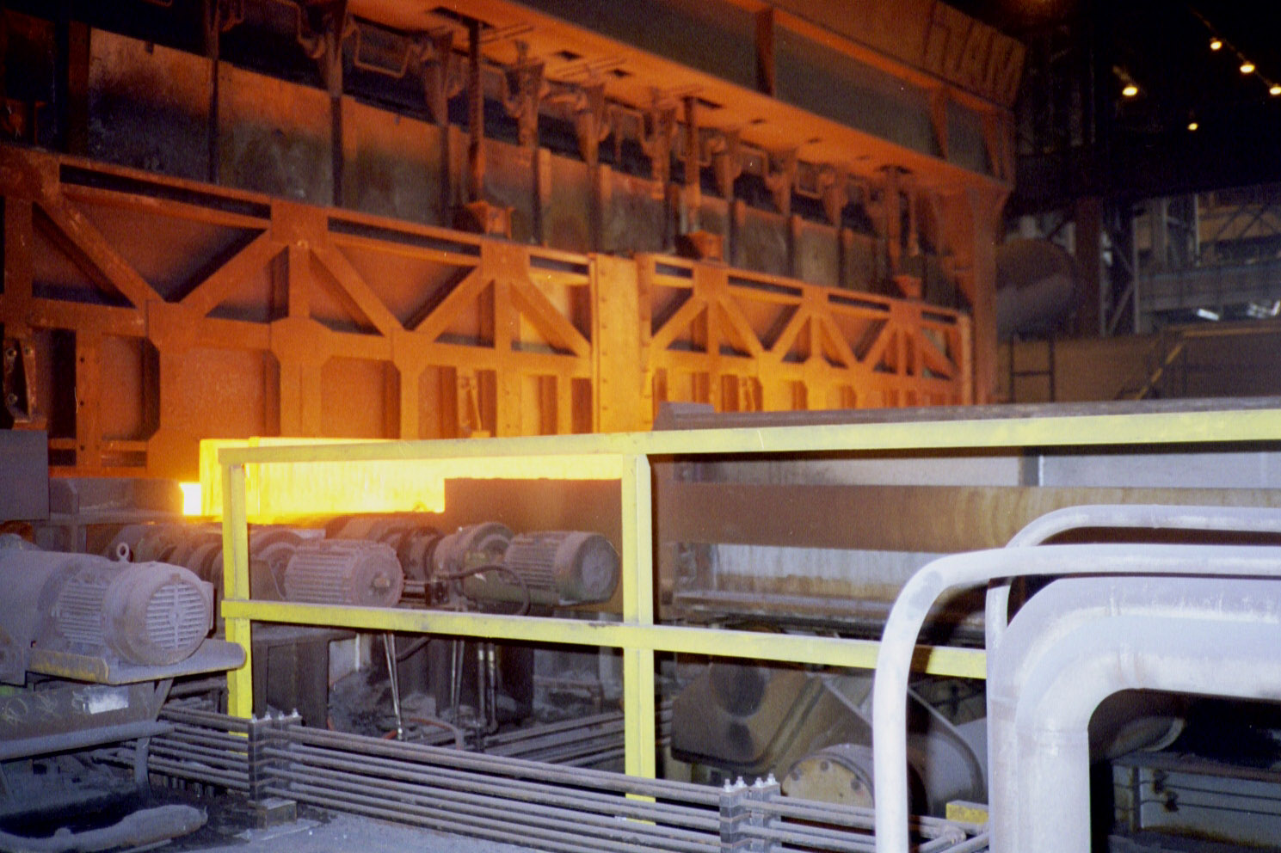
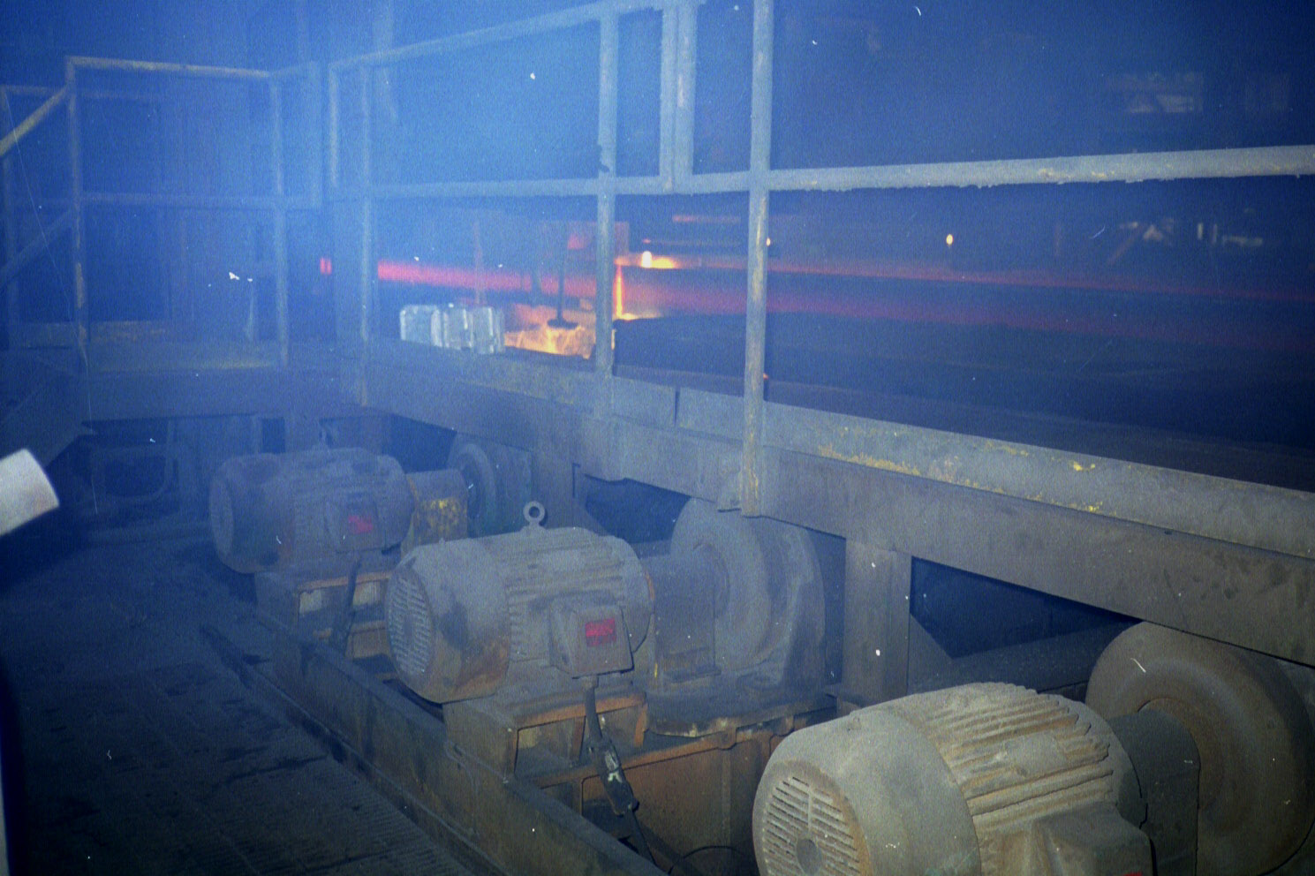
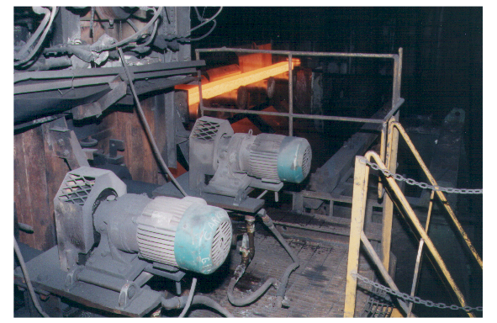

Fig. 7

NUCOR-YAMATO

REHEAT FURNACE
- MODEL #CHH-4175Y-SB-35
- MOTOR – 15 HP C-FACED
- QTY (20)

Fig. 8

REHEAT FURNACE

DISCHARGE CONVEYOR
- 15 HP INTEGRAL MOTOR

Fig. 9

RUNOUT TABLE

ROLLER CONVEYOR
- MODEL #CHH-4205Y-43
- MOTOR – 15 HP
- QTY (54)

Fig. 11

FINISHING END

SHEAR INFEED ROLLS

MODEL CHH-4155Y-11

1 HP MOTOR

QTY (36)

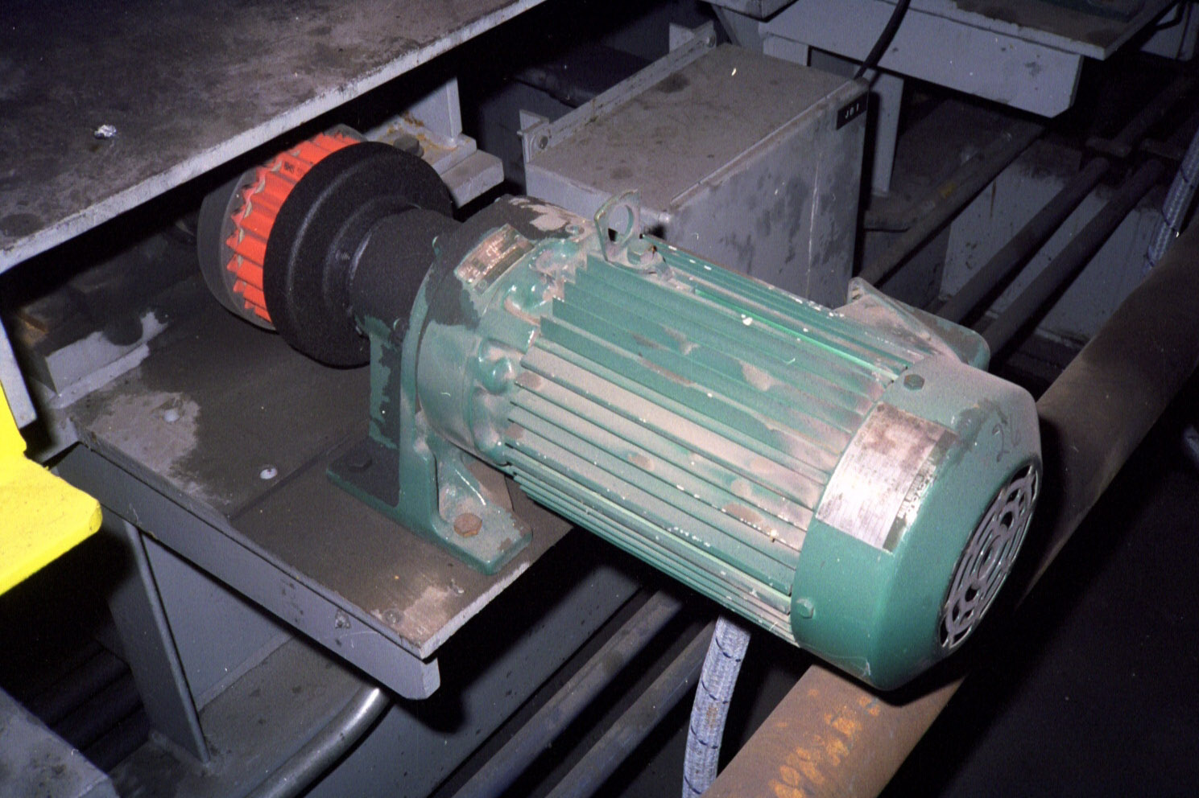
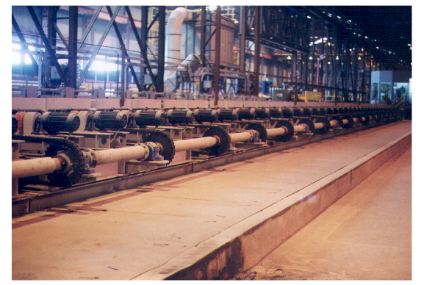
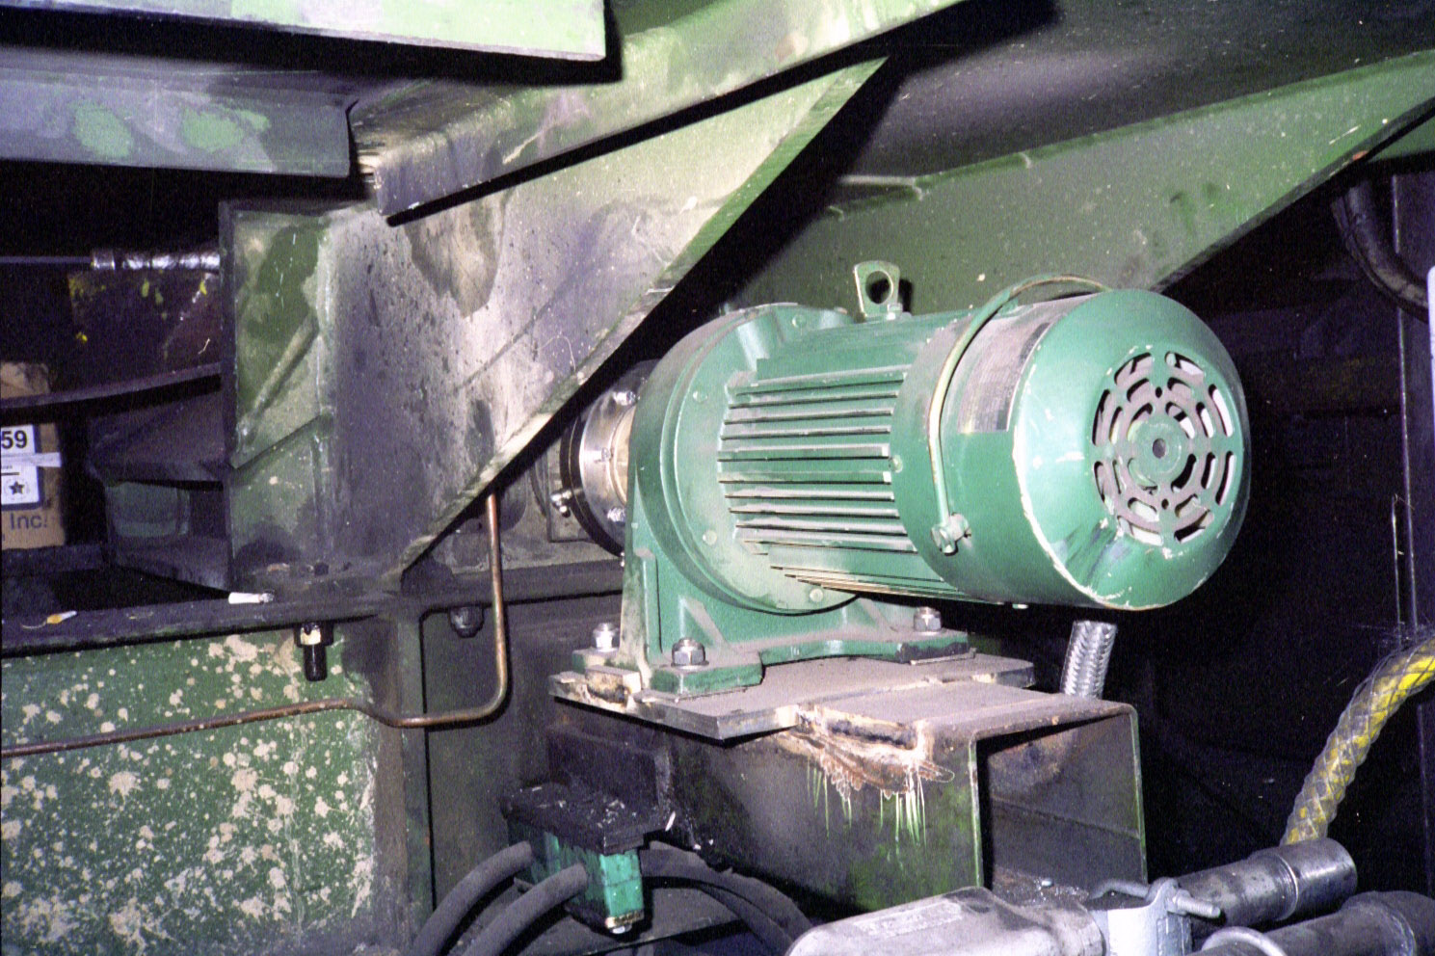

Fig. 10

AMERISTEEL

ROLL TRANSFER TABLE

MODEL CNHM2-4115Y-21

2 HP INTEGRAL MOTOR

GREASE PACKED

QTY (30)

Fig. 12

AMERISTEEL BUNDLE

TRANSFER TABLE

CNHM2-4115Y-AV-B-51

2 HP INTEGRAL MOTOR

GREASE PACKED

QTY (24)

Customization Capability:
Customization is common when dealing with the many design parameters of diverse applications. Over the years, Sumitomo has partnered with our customers to provide unique solutions for demanding applications. In many cases, we are requested to provide “drop-in” reducers for obsolete equipment. Because the Cyclo is compact and power dense, we can offer many design modifications to fulfill these special requirements.

Solutions requiring unique modifications have been made to the following:
- Housing material
  - Standard is Grey Cast Iron
  - Ductile Iron Housings are available
- Input and Output Shaft Dimensions (Length and Diameter)
- Overall Gearbox Length
- Bolt Holes
- Transition Bases
- Base Plates to meet certain base to center requirements
- Special Mounting Adapters
- Special C-Face Adapters

The Sumitomo solution to “drop-in” for various speed reducer manufacturers is made possible by the Cyclo’s unique “F” flange design [Fig. 13]. The “F” flange Cyclo is used in conjunction with a fabricated “Steelfoot” adapter [Fig. 14] to create a customized foot bolt-pattern that match most manufacturers.

Fig .13 Fig. 14

STANDARD FLANGE CYCLO® 6000 FABRICATED STEELFOOT
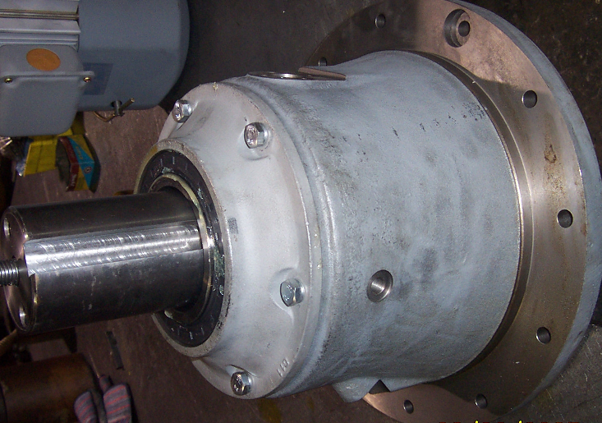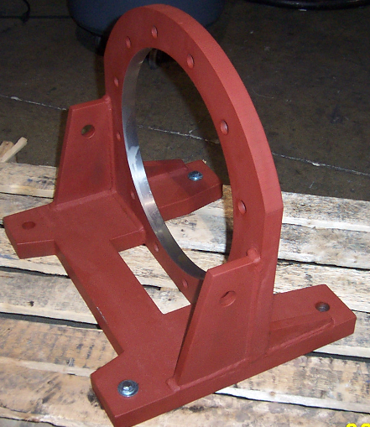

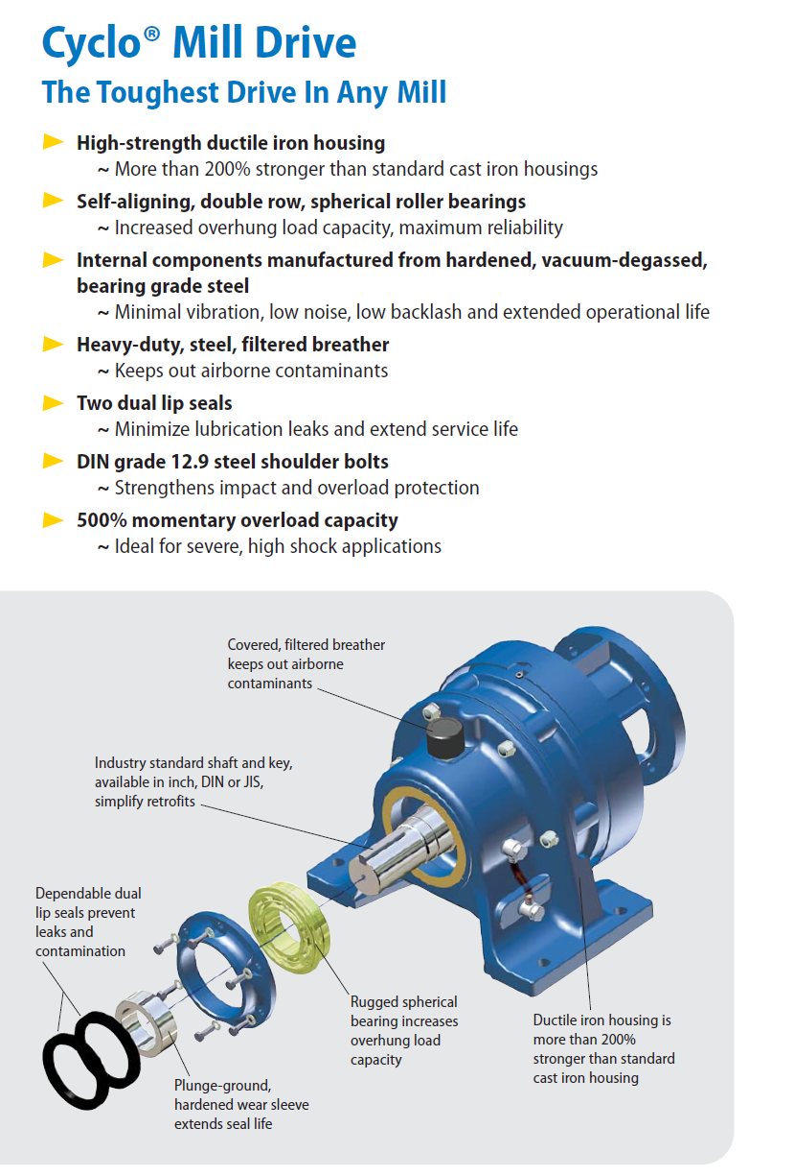

Sumitomo Drive Technologies:
For more than 100 years, SUMITOMO has been the premier manufacturer of Power Transmission Components for worldwide steel industry.

Our U.S. headquarters is in Chesapeake, Virginia and we have approximately 3,000 employees located at nine (9) manufacturing facilities worldwide. Our products are sold around the world by over 200 direct sales representatives through a network of 28 Assembly Centers backed by hundreds of qualified stocking distributors.

SUMITOMO has an industry focused sales team committed to serving the steel industry.

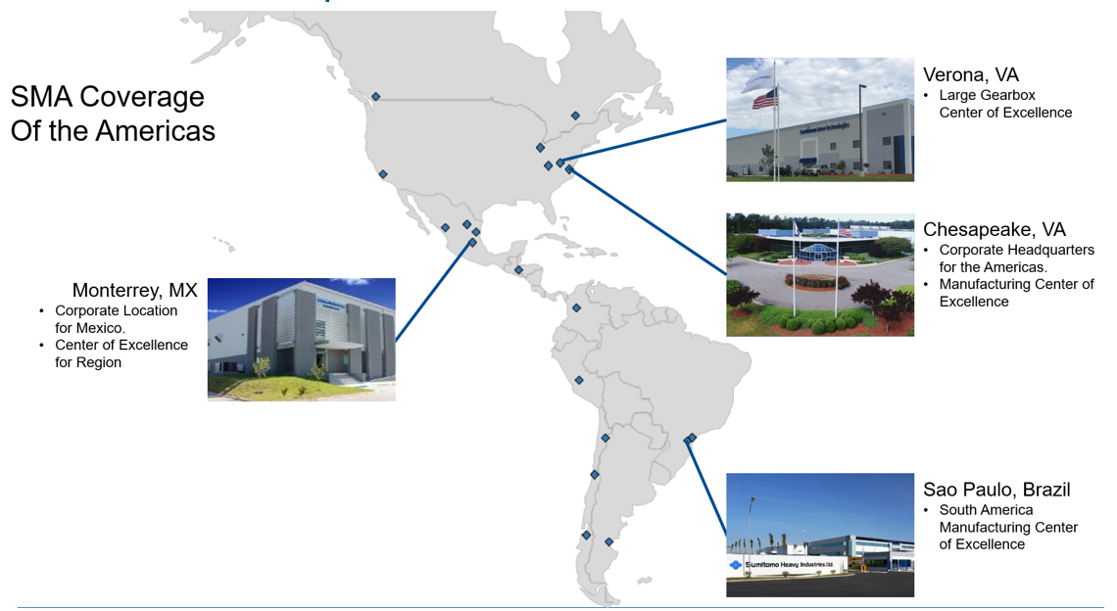



www.sumitomodrive.com

